# Applecross Senior High School

### Semester One Examination, 2018

### Question/Answer booklet

# MATHEMATICS

**SOLUTIONS**

**METHODS**

**UNIT 1**

## Section One:

## Calculator-free

|  |  |  |  |  |  |  |  |  |  |  |
| --- | --- | --- | --- | --- | --- | --- | --- | --- | --- | --- |
| Student number: In figures |  |  |  |  |  |  |  |  |  |  |

In words

Your name

## Time allowed for this section

Reading time before commencing work: five minutes

Working time: fifty minutes

## Materials required/recommended for this section

***To be provided by the supervisor***

This Question/Answer booklet

Formula sheet

***To be provided by the candidate***

Standard items: pens (blue/black preferred), pencils (including coloured), sharpener,  
correction fluid/tape, eraser, ruler, highlighters

Special items: nil

## Important note to candidates

No other items may be taken into the examination room. It is **your** responsibility to ensure that you do not have any unauthorised material. If you have any unauthorised material with you, hand it to the supervisor **before** reading any further.

## Structure of this paper

|  |  |  |  |  |  |
| --- | --- | --- | --- | --- | --- |
| Section | Number of questions available | Number of questions to be answered | Working  time (minutes) | Marks available | Percentage of examination |
| Section One:  Calculator-free | 8 | 8 | 50 | 52 | 35 |
| Section Two:  Calculator-assumed | 13 | 13 | 100 | 98 | 65 |
|  | | |  | **Total** | 100 |

## Instructions to candidates

1. The rules for the conduct of examinations are detailed in the school handbook. Sitting this examination implies that you agree to abide by these rules.

2. Write your answers in this Question/Answer booklet.

3. You must be careful to confine your response to the specific question asked and to follow any instructions that are specified to a particular question.

4. Supplementary pages for the use of planning/continuing your answer to a question  
have been provided at the end of this Question/Answer booklet. If you use these pages to continue an answer, indicate at the original answer where the answer is continued, i.e. give the page number.

5. Show all your working clearly. Your working should be in sufficient detail to allow your answers to be checked readily and for marks to be awarded for reasoning. Incorrect answers given without supporting reasoning cannot be allocated any marks. For any question or part question worth more than two marks, valid working or justification is required to receive full marks. If you repeat any question, ensure that you cancel the answer you do not wish to have marked.

6. It is recommended that you do not use pencil, except in diagrams.

7. The Formula sheet is not to be handed in with your Question/Answer booklet.

Section One: Calculator-free 35% (52 Marks)

This section has**eight (****8)** questions. Answer **all** questions. Write your answers in the spaces provided.

Working time: 50 minutes.

Question 1 (5 marks)

(a) Solve $5\left(2t+1\right)-3\left(t-4\right)=0$ for $t$. (2 marks)

|  |
| --- |
| **Solution** |
| $$10t+5-3t+12=0 \\ 7t+17=0$$ $$t=-\frac{17}{7}$$ |
| **Specific behaviours** |
| ✓ expands and simplifies correctly  ✓ solves for $t$ |

(b) Solve $\begin{matrix}7 \\ \overline{a-5}\end{matrix}-\begin{matrix}3 \\ \overline{4a}\end{matrix}=0$ for $a$. (3 marks)

|  |
| --- |
| **Solution** |
| $$\begin{matrix}7 \\ \overline{a-5}\end{matrix}=\begin{matrix}3 \\ \overline{4a}\end{matrix}⇒28a=3\left(a-5\right)$$ $$28a=3a-15 \\ 25a=-15$$ $$a=-\frac{15}{25}=-\frac{3}{5}$$ |
| **Specific behaviours** |
| ✓ cross-multiplies  ✓ expands and simplifies  ✓ solves for $a$ |

Question 2 (5 marks)

Solve the following equations.

(a) $6x^{2}=3x$. (2 marks)

|  |
| --- |
| **Solution** |
| $$3x\left(2x-1\right)=0$$ $$x=0, x=\frac{1}{2}$$ |
| **Specific behaviours** |
| ✓ equates to zero and factorises  ✓ solutions |

(b) $x\left(x+2\right)=24$. (3 marks)

|  |
| --- |
| **Solution** |
| $$x^{2}+2x-24=0$$ $$\left(x+6\right)\left(x-4\right)=0$$ $$x=-6, x=4$$ |
| **Specific behaviours** |
| ✓ expands and equates to zero  ✓ factorises  ✓ solutions |

Question 3 (6 marks)

A function is defined by $f\left(x\right)=\sqrt{3x}$.

(a) Calculate $f(12)$. (1 mark)

|  |
| --- |
| **Solution** |
| $$f\left(12\right)=\sqrt{36}=6$$ |
| **Specific behaviours** |
| ✓ correct value |

(b) State the domain and range of $f(x)$. (2 marks)

|  |
| --- |
| **Solution** |
| $$D_{f}:x≥0, R_{f}:f(x)≥0$$ |
| **Specific behaviours** |
| ✓ domain, ✓ range |

(c) Sketch the graph of $y=f(x)$ on the axes below. (3 marks)

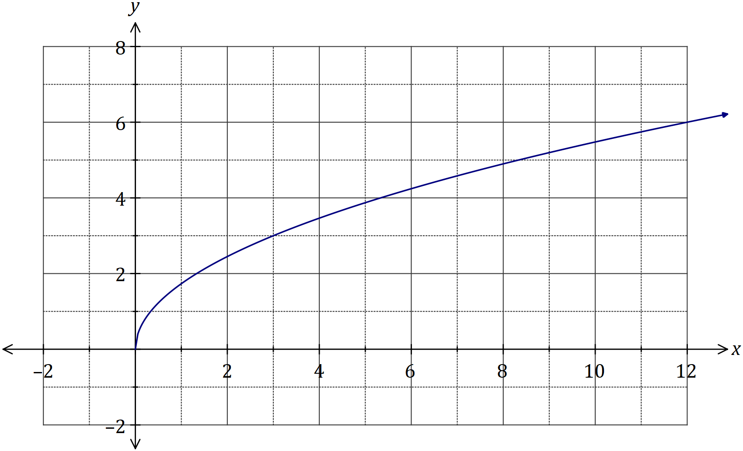

|  |
| --- |
| **Solution** |
| See graph |
| **Specific behaviours** |
| ✓ starts at (0,0)  ✓ passes through (3, 3) and (12, 6)  ✓ smooth curve |

Question 4 (5 marks)

The graph of the line $L_{1}$ is shown below.

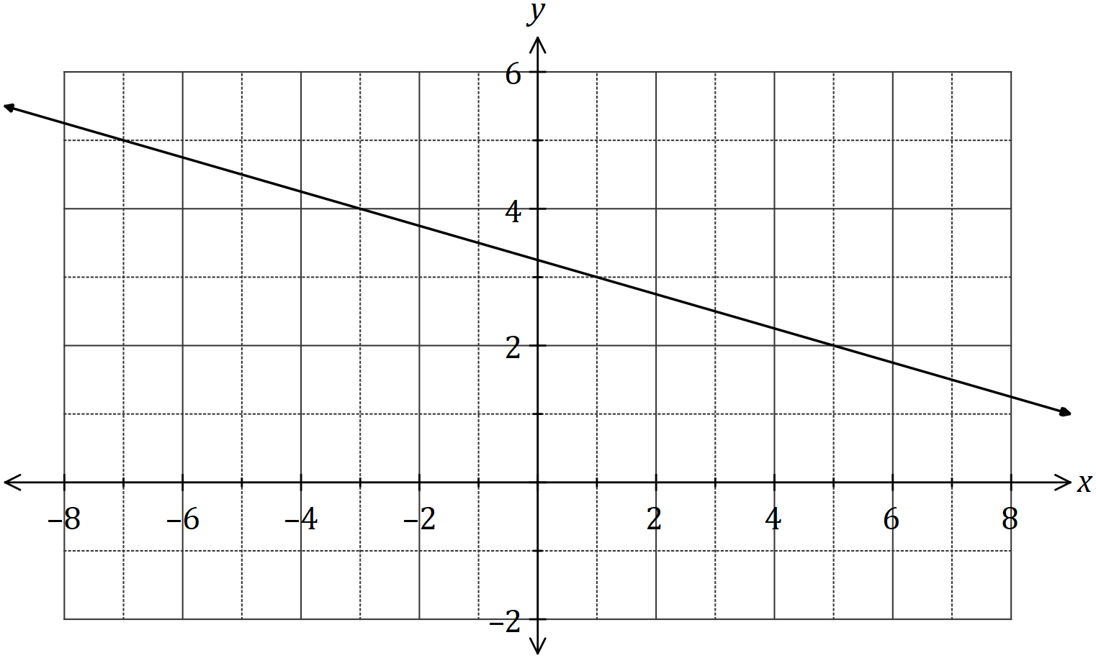

(a) Determine the equation of $L_{1}$. (2 marks)

|  |
| --- |
| **Solution** |
| $$m=-\frac{1}{4}$$ $$y-3=-\frac{1}{4}(x-1) \\ y=-\frac{1}{4}x+\frac{13}{4}$$ |
| **Specific behaviours** |
| ✓ gradient  ✓ correct equation (any form) |

Two points are located at $A(-10, 5)$ and $B(6, 29)$.

(b) Line $L_{2}$ is perpendicular to $L_{1}$ and passes through the mid-point of $A$ and $B$. Determine the equation of $L_{2}$. (3 marks)

|  |
| --- |
| **Solution** |
| $$M\left(-2, 17\right)$$ $$m=-1÷\left(-\frac{1}{4}\right)=4$$ $$y-17=4\left(x-\left(-2\right)\right) \\ y=4x+25$$ |
| **Specific behaviours** |
| ✓ coordinates of midpoint  ✓ perpendicular gradient  ✓ equation of line (any form) |

Question 5 (6 marks)

(a) Expand and simplify $(x+2)(2x-5)(x-2)$. (2 marks)

|  |
| --- |
| **Solution** |
| $$\left(x+2\right)\left(2x-5\right)\left(x-2\right)=\left(2x-5\right)\left(x^{2}-4\right)$$ $$=2x^{3}-{5x}^{2}-8x+20$$ |
| **Specific behaviours** |
| ✓ expands one pair of terms  ✓ simplified expansion |

(b) One solution to the equation $x^{3}+36=5x^{2}+12x$ is $x=2$. Determine all other solutions.

(4 marks)

|  |
| --- |
| **Solution** |
| $$x^{3}-5x^{2}-12x+36=0$$ $$\left(x-2\right)\left(x^{2}+ax-18\right)=0$$ $$-2+a=-5⇒a=-3$$ $$\left(x-2\right)\left(x^{2}-3x-18\right)=0$$ $$\left(x-2\right)\left(x-6\right)\left(x+3\right)=0$$ $$\text{Other solutions: }x=6, x=-3$$ |
| **Specific behaviours** |
| ✓ equates to zero and identifies $(x-2)$ as a factor  ✓ factors out quadratic expression  ✓ identifies value of  ✓ factors quadratic and states other two solutions |

Question 6 (9 marks)

(a) Solve the equation $\sqrt{3}\tan{(x)}-3=0$ for $0≤x≤2π$. (3 marks)

|  |
| --- |
| **Solution** |
| $$\tan{x}=\frac{3}{\sqrt{3}}=\sqrt{3}$$ $$x=\frac{π}{3},\frac{4π}{3}$$ |
| **Specific behaviours** |
| ✓ expression for  ✓ one solution  ✓ second solution (penalise once for use of degrees) |

(b) A function has a period of $k$ and is defined by $f\left(x\right)=4\cos{(2x)}$.

(i) State the value of $k$. (1 mark)

|  |
| --- |
| **Solution** |
| (i) $k=\frac{2π}{2}=π \text{or} k=\frac{360}{2}=180°$ (ii) Amplitude is $4$ |
| **Specific behaviours** |
| ✓ period (either unit)  ✓ amplitude |

(ii) State the amplitude of $f(x)$. (1 mark)

(iii) Sketch the graph of $y=f(x)$ over the domain $-k≤x≤k$. (4 marks)

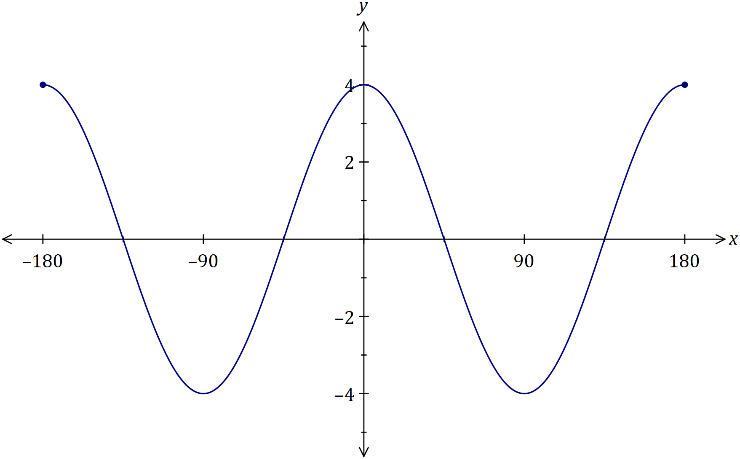

|  |
| --- |
| **Solution** |
| See graph *(student choice of radians or degrees)* |
| **Specific behaviours** |
| ✓ amplitude correct, with scale indicated  ✓ axes intercepts, with scale indicated  ✓ two complete cycles (no penalty for slightly exceeding domain  ✓ smooth curve |

Question 7 (9 marks)

(a) Determine the coordinates of the $y$-axis intercept of the line $3x+5y-11=0$. (2 marks)

|  |
| --- |
| **Solution** |
| $$x=0, 5y-11=0⇒y=\frac{11}{5}$$ $$\left(0,\frac{11}{5}\right)≡(0, 2.2)$$ |
| **Specific behaviours** |
| ✓ simplifies by substituting  ✓ correct coordinates |

(b) A quadratic function is given by $y=(x-1)(x+4)$. For the graph of this function, determine

(i) the coordinates of the $y$-axis intercept. (1 mark)

|  |
| --- |
| **Solution** |
| $$x=0, y=\left(-1\right)\left(4\right)=-4$$ $$\left(0, -4\right)$$ |
| **Specific behaviours** |
| ✓ correct coordinates |

(ii) the coordinates of the zeros (ie the $x$ intercepts). (2 marks)

|  |
| --- |
| **Solution** |
| $$y=0⇒x=1, -4$$ $$\left(1, 0\right)\text{ and }\left(-4, 0\right)$$ |
| **Specific behaviours** |
| ✓ indicates zeros  ✓ writes as coordinates |

(iii) the equation of the axes of symmetry. (2 marks)

|  |
| --- |
| **Solution** |
| $$x=\frac{1+\left(-4\right)}{2}=-\frac{3}{2}$$ $$x=-1.5$$ |
| **Specific behaviours** |
| ✓ averages zeros  ✓ writes as equation |

(iv) the coordinates of the turning point. (2 marks)

|  |
| --- |
| **Solution** |
| $$y=\left(-1.5-1\right)\left(-1.5+4\right) \\ =-2.5×2.5=-\frac{5}{2}×\frac{5}{2}=-\frac{25}{4}$$ $$\left(-1.5, -6.25\right)≡\left(-\frac{3}{2}, -\frac{25}{4}\right)$$ |
| **Specific behaviours** |
| ✓ substitutes $x$-coordinate  ✓ correct coordinates |

Question 8 (7 marks)

(a) The graph of the relation $y^{2}=x$ passes through the points $\left(16,a\right)$ and $(b, -5)$. Determine the values of $a$ and $b$. (3 marks)

|  |
| --- |
| **Solution** |
| $$a^{2}=16⇒a=4, a=-4$$ $${\left(-5\right)}^{2}=b⇒b=25$$ |
| **Specific behaviours** |
| ✓ one value of  ✓ both values of  ✓ value of $b$ |

(b) Another relation is defined by ${\left(x-1\right)}^{2}+{\left(y+2\right)}^{2}=4$.

(i) Sketch the graph of this relation on the axes below. (3 marks)

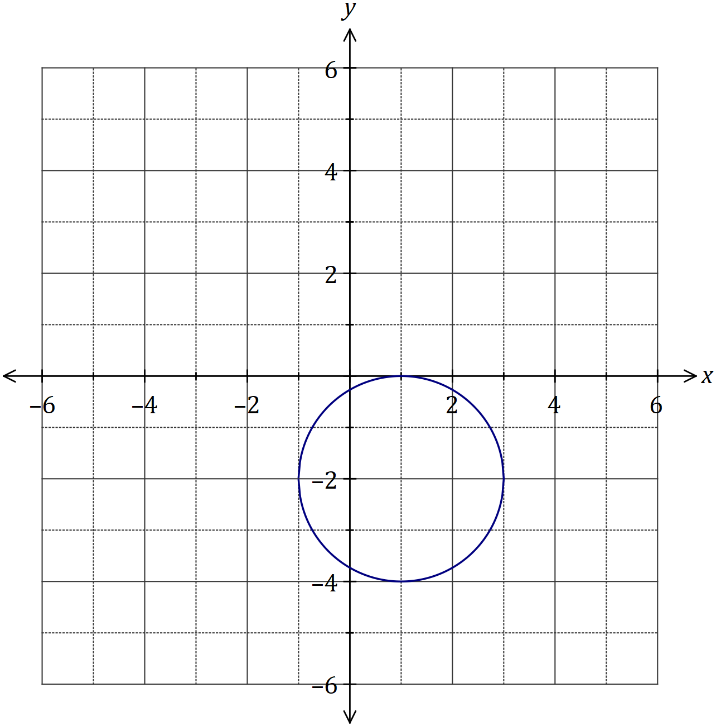

|  |
| --- |
| **Solution** |
| See graph |
| **Specific behaviours** |
| ✓ centre  ✓ radius  ✓ reasonably smooth circle |

(ii) What feature of the graph indicates that a relation rather than a function is shown? (1 mark)

|  |
| --- |
| **Solution** |
| A vertical line can be drawn that intersects the circle more than once, and thus shows a relation. |
| **Specific behaviours** |
| ✓ uses vertical line test |

Supplementary page

Question number: _________

© 2018 WA Exam Papers. Applecross Senior High School has a non-exclusive licence to copy and communicate this document for non-commercial, educational use within the school. No other copying, communication or use is permitted without the express written permission of WA Exam Papers. SN002-112-2.